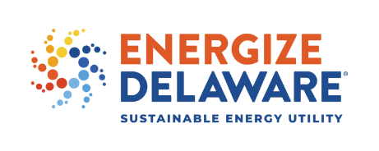

Executive Director’s Report
May – August 2020

- Commercial PACE – In July, our 2nd C-PACE project was financing closed; this was a $3 million second phase energy saving project for the Dupont Hotel property. In addition, we are currently in discussion with Kent County about becoming a participating county.

- First Master Lease Finance Deal Closes - On August 20th we closed the lease finance deal for the Department of Corrections, Phase II Energy Saving Performance Contract. This was a $3,186,355 project financed by Bank of American through our new Framework Agreement (Master Lease). Like a bond issue the DESEU receives a ½% percent service fee. We have already begun are second financing deal with DHSS for $13.2 million project.

- Mike Williams Moving On – Mike has taken a public relations position with CR school district. He had been with us on part time basis for nearly two years. He has agreed to continue managing our social media sites for us from home. I am not looking to fill his position. At this point I want to see how things work out using Mike in a reduced capacity and ABC for certain tasks like the annual report. Athena is able to help with website matters.

- FY 20-21 Marketing Plan – We are continuing our marketing plan with ABC. This year we decided to scale back our overall brand awareness campaign and increase marketing support for certain programs that can assistance including Non-Profit Assessments, Faith Efficiencies, Empowerment, and Multi-Family. We have dropped print and radio advertising and increased social media. We will continue with billboards.

- COVID related actions – In addition to all the actions previously reported, we decided to waive fees for non-profit organization that want to go through our audit programs. Also, since approving loan deferment policy we have received no new requests, of the five approved deferrals, four are back to paying us regularly

- Newark Energy Treasure Hunt – We are funding this small business pilot program under our R&D budget. We currently do not offer a small business program. Through a small startup non-profit centered at the University of Delaware ten small business in Newark will got through an energy audit and bill analysis, receive energy counseling, and agree to having their businesses sub metered. They will also be given access to an “APP” to help them monitor their energy saving progress. The businesses will compete for prizes based on energy savings. The Pilot should be done by the end of the year and we will provide an analysis to the board.

- Strategic Plan - The staff continues to work on the Strategic Plan update. We are entering into a small contract with the UD Institute of Public Policy to assess the state of sustainability planning in Delaware. Athena has been working hard at gathering data from a wide variety of reports and projections and working on a way to assess the impact of our programs on those projections. We have also been going through the 2015 plan determining what sections eliminated, updated, or added. We have developed aTable of Contents that serves as a general outline.

